# Speed Control Model

diyagram, metin, plan, dikdörtgen içeren bir resim

Açıklama otomatik olarak oluşturuldu

Figure 30: Simulation Model for Speed Control

**NOTE: Motor current is not limited in this model however since the current rating of the motor is 23A this current should be limited which will cause output power to be even less. Furthermore, diode MOSFET currents will be more realizable like in the speed controller. Due to assumed parameters in motor and generator the loss is great and only 2kW can be generated from 10kW**

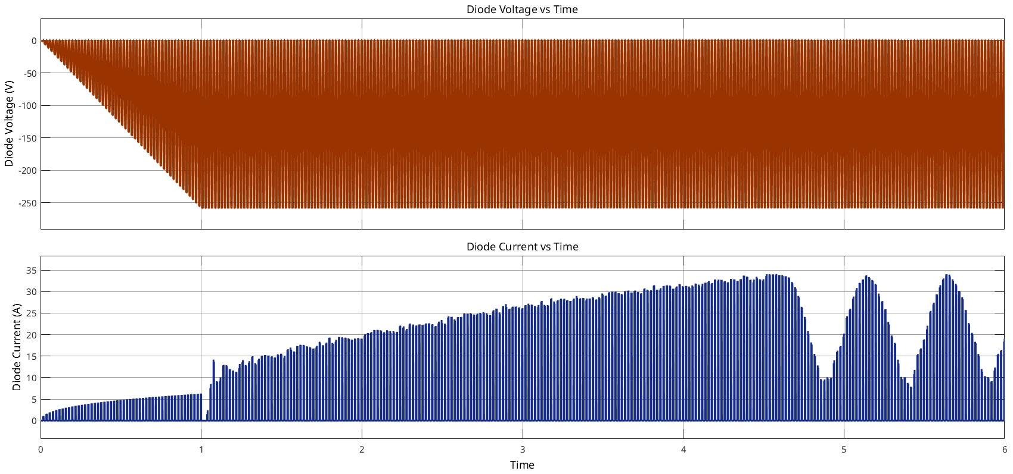

Figure 31: Voltage and Current on the Diode

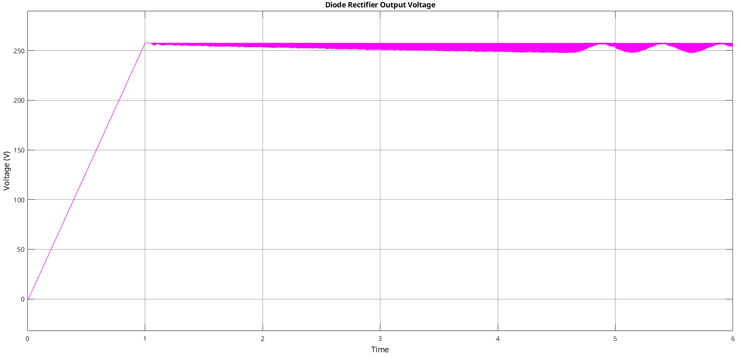

Figure 32: Rectifier Output Voltage

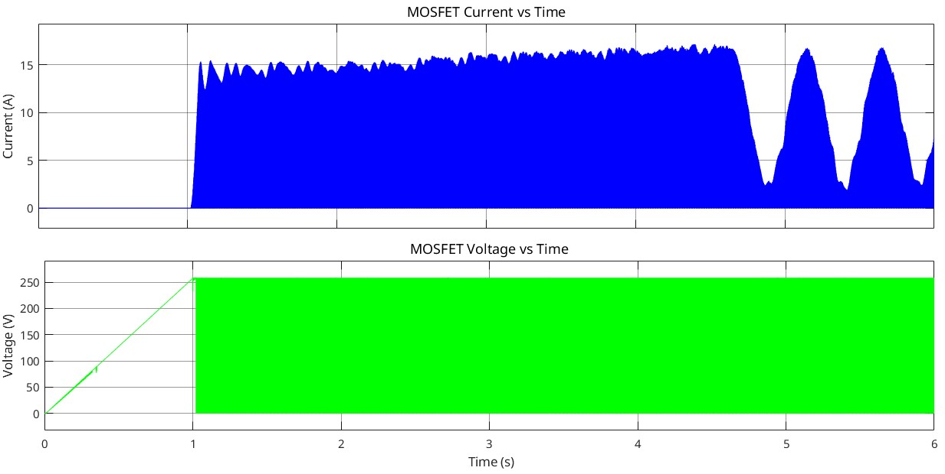

Figure 33. Voltage and Current on the MOSFET

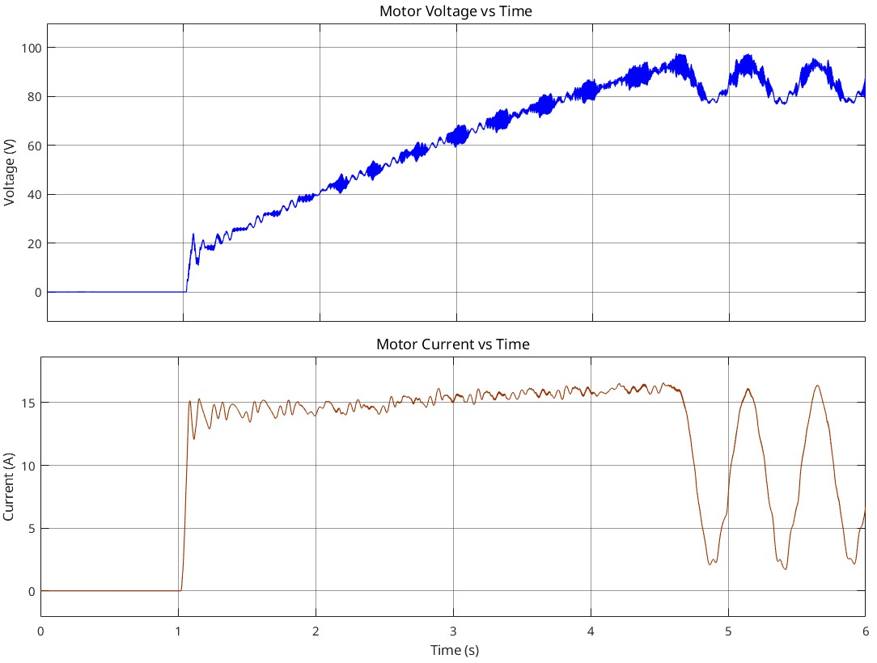

Figure 34. Voltage and Current on the Motor

(ripples after the 4.5s is caused by speed oscillations around 150 rad/s speed controller should be optimized)

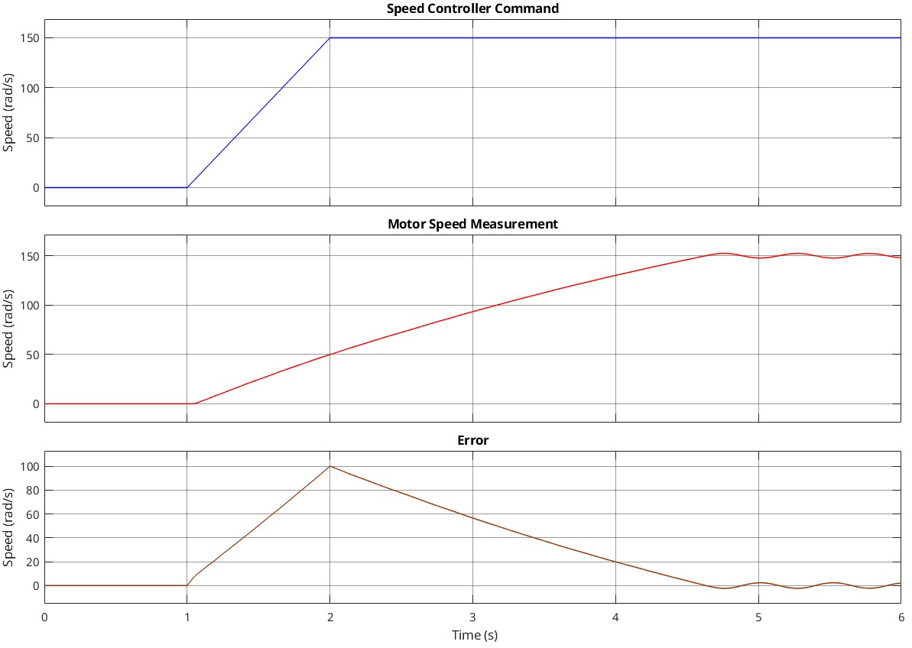

Figure 35. Speed Controller Command, Measurement, and Error

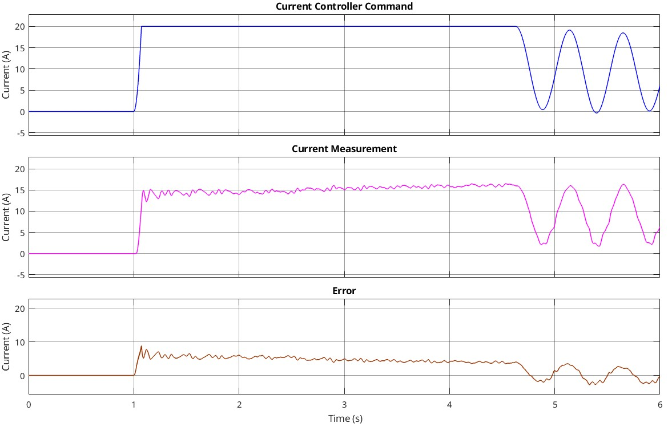

Figure 36. Current Controller Command, Measurement, and Error

The speed control model is constructed for 150 rad/s speed control (desired speed of the motor) which is calculated as 157 rad/s (rated) according to the configuration and parameters of the motor. Speed controller command and the speed result can be seen at figure 35. According to figures 31-32-33 our motor driver starts to work but at the second 1 (1 second after we give the electricity to the driver) it starts to excite motor. At figure 31 it is clear that we charge the capacitors until the end of the 1st second, and figure 32 (rectifier output voltage graph) Figure 33 (MOSFET Voltage) shows us this capacitor charging process. We can understand that until our system comes to the excitation point there is no current flow through motor (from figure 34) and no speed at the rotor of the motor (figure 35).

This information tells us that we need diodes for the three-phase rectifier which can stop 250 V reverse voltage and let 35 A current at least. Of course we should think about the safety margin which can be thought of as 20-25%. Therefore, we should select diodes of the rectifier as 300-320 V voltage and 42-45 A simulation result values in safety margin. From figure 33, we can think about MOSFET parameters. The voltage value of the MOSFET should be 255*1.2 or 255*1.25 V voltage in safety margin which implies 305-325 V, and 17*1.2 or 17*1.25 A current in safety margin which implies 20-22 A.

For security there is current control for the motor which can be seen from figure 36. We set the limit as 20A to be able to prevent any problem on the motor since it will be 20A*180V = 3.6kW power on the motor (which can be thought as 9 times desired value, also almost 2 times of the tea bonus desired value). However, the buck converter output voltage should not be thought of as motor input voltage (current also), figure 34 shows us the current and voltage value of the motor and we can say there is 1.2-1.5 kW power on the motor (80V*15A or 100V*15A).

# Generator Model

metin, diyagram, plan, ekran görüntüsü içeren bir resim

Açıklama otomatik olarak oluşturuldu

Figure 37. Simulation Model for Generator

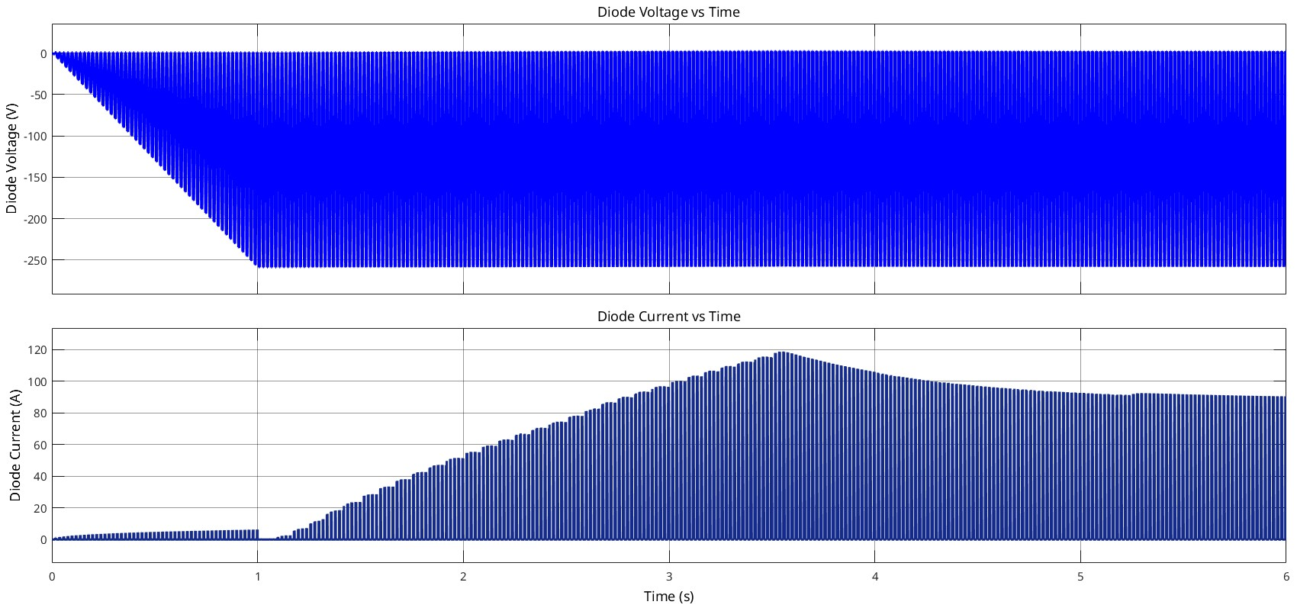

Figure 38. Voltage and Current on the Diode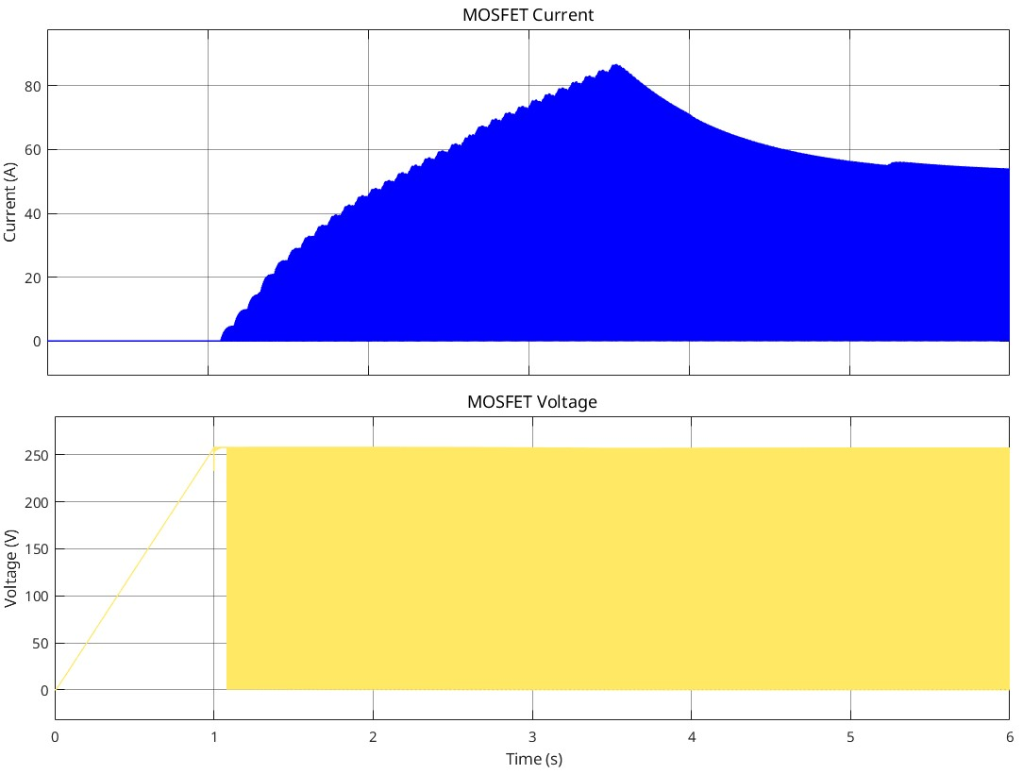

Figure 39. Voltage and Current on the MOSFET

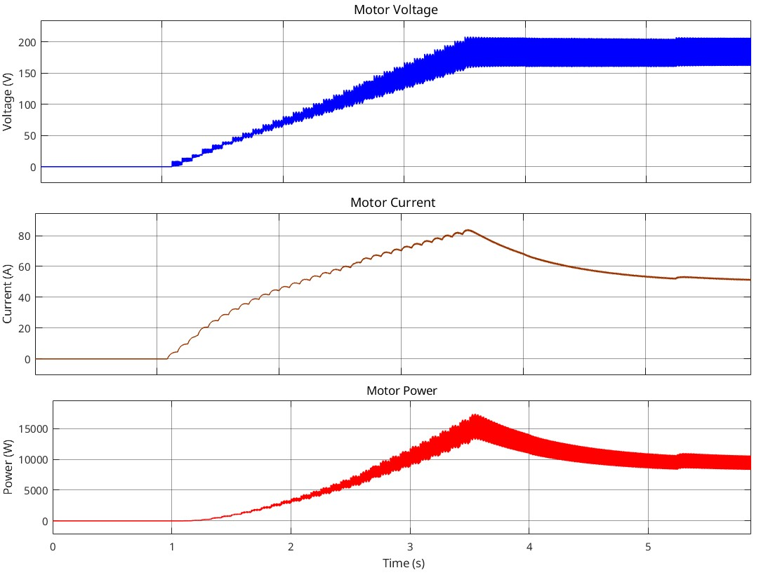

Figure 40. Voltage, Current, and Power of the Motor

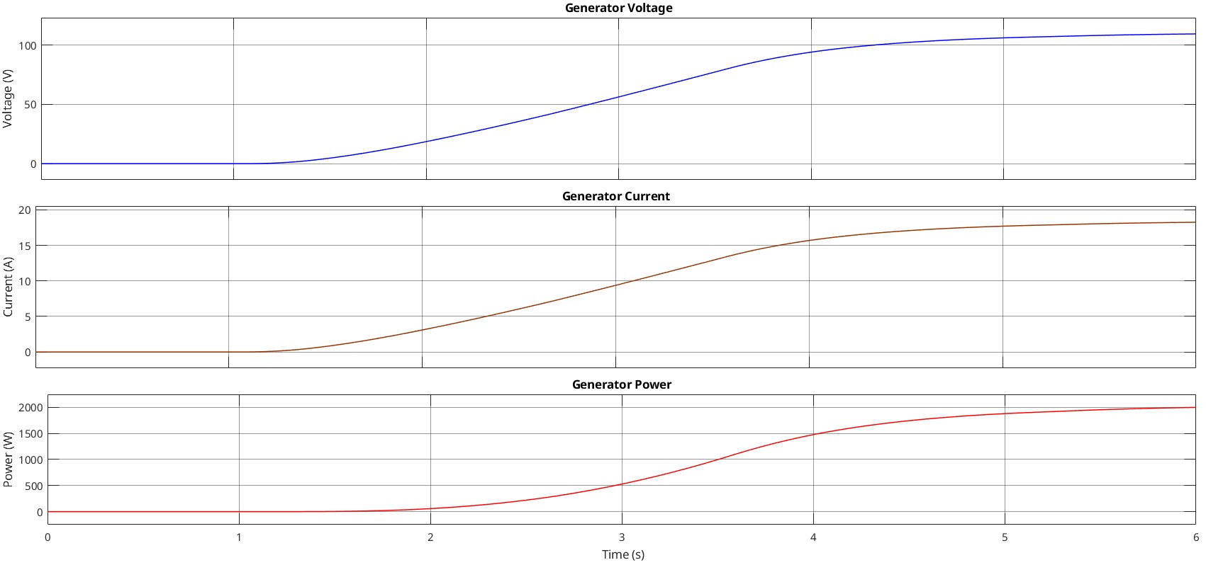

Figure 41. Voltage, Current, and Power of the Generator

This model (Figure 37) is constructed for generator mode. We drive the motor thanks to rectifier + buck converter and this motor rotates the generator to push it generate power. For this configuration we can say output (motor + generator system is output part, rectifier + buck converter system is input part) of the system requires more power from the input, so we see while the diodes voltages are the same with motor model, current demand is increased (figure 38) to be able to increase input power (figure 40). Diode current increased up to 90 A for this operation while the voltage is around 255 V. MOSFET current is also increased up to 50 A while the voltage is around 255 V.

For this operation motor voltage, current and power are at the figure 40 and they are around 180 V, 50 A and 9 kW respectively. For these motor results we can only take 2 kW generator power, while the current and voltage of the generator are 18A and 110V respectively.

As it was indicated at the beginning of the controller simulation part, motor rated current is 23 A, and this means that we cannot operate the motor and generator as we found from the simulation. 90 A current for the motor is not possible therefore these results are not valid for this project.